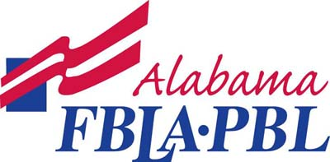
(SCHOOL NAME)
(YEAR)

SAMPLE PROGRAM OF WORK

PROGRAM COMPONENT: Local Participation
OBJECTIVE | ACTION | TARGET DATE | PEOPLE INVOLVED | BUDGET | Blueprint  CONNECTION
Student Growth | Planning session with newly elected officers | August 30 | All officers and advisers | 0
 | Planning session with officers | September 6 | All officers and advisers | 0
 | Chapter Meetings | September 13  October 11  November 8  December 6  January 10  February 7  March 7  April 4 | All officers and available advisers | 0
Recognition | Honor an outstanding chapter member monthly | Monthly | Members | 0
Social | Business related fieldtrip to Marketing Day at Six Flags | April | Members and advisers | TBD
 | “Get to Know You” ice cream social | August | Members and advisers | TBD
Community Service | Susan B. Komen Breast Cancer 3K | October | Members and advisers
 | Can food drive | November 2 | Members and advisers
Public Relations | FBLA School Website with Calendar of Events | September | Officers and advisers
 | Design a chapter T-shirt | September | Officers and advisers
 | Submit an article to the local newspaper | October | Secretary

PROGRAM COMPONENT: State Participation
OBJECTIVE | ACTION | TARGET DATE | PEOPLE INVOLVED | BUDGET | Blueprint  CONNECTION
Student Growth | Attend JLDC | September 24-25 | Members and advisers | TBD
 | Affiliate with the State |  | Members and adviser | TBD

PROGRAM COMPONENT: National Participation
OBJECTIVE | ACTION | TARGET DATE | PEOPLE INVOLVED | BUDGET | Blueprint  CONNECTION
Student Growth- financial literacy | Fall Stock Market Game and Virtual Business Challenge | September |  | 0
Student Growth | National Fall Leadership Conference | November 9-10 |  | TBD

PROGRAM COMPONENT: Fundraising
OBJECTIVE | ACTION | TARGET DATE | PEOPLE INVOLVED | BUDGET | Blueprint  CONNECTION
March of Dimes Goal $2000.00 | Blue Jeans for Babies | December | All members | $2000.00
Local funds | Christmas Wreaths | November | All members | $1500.00

