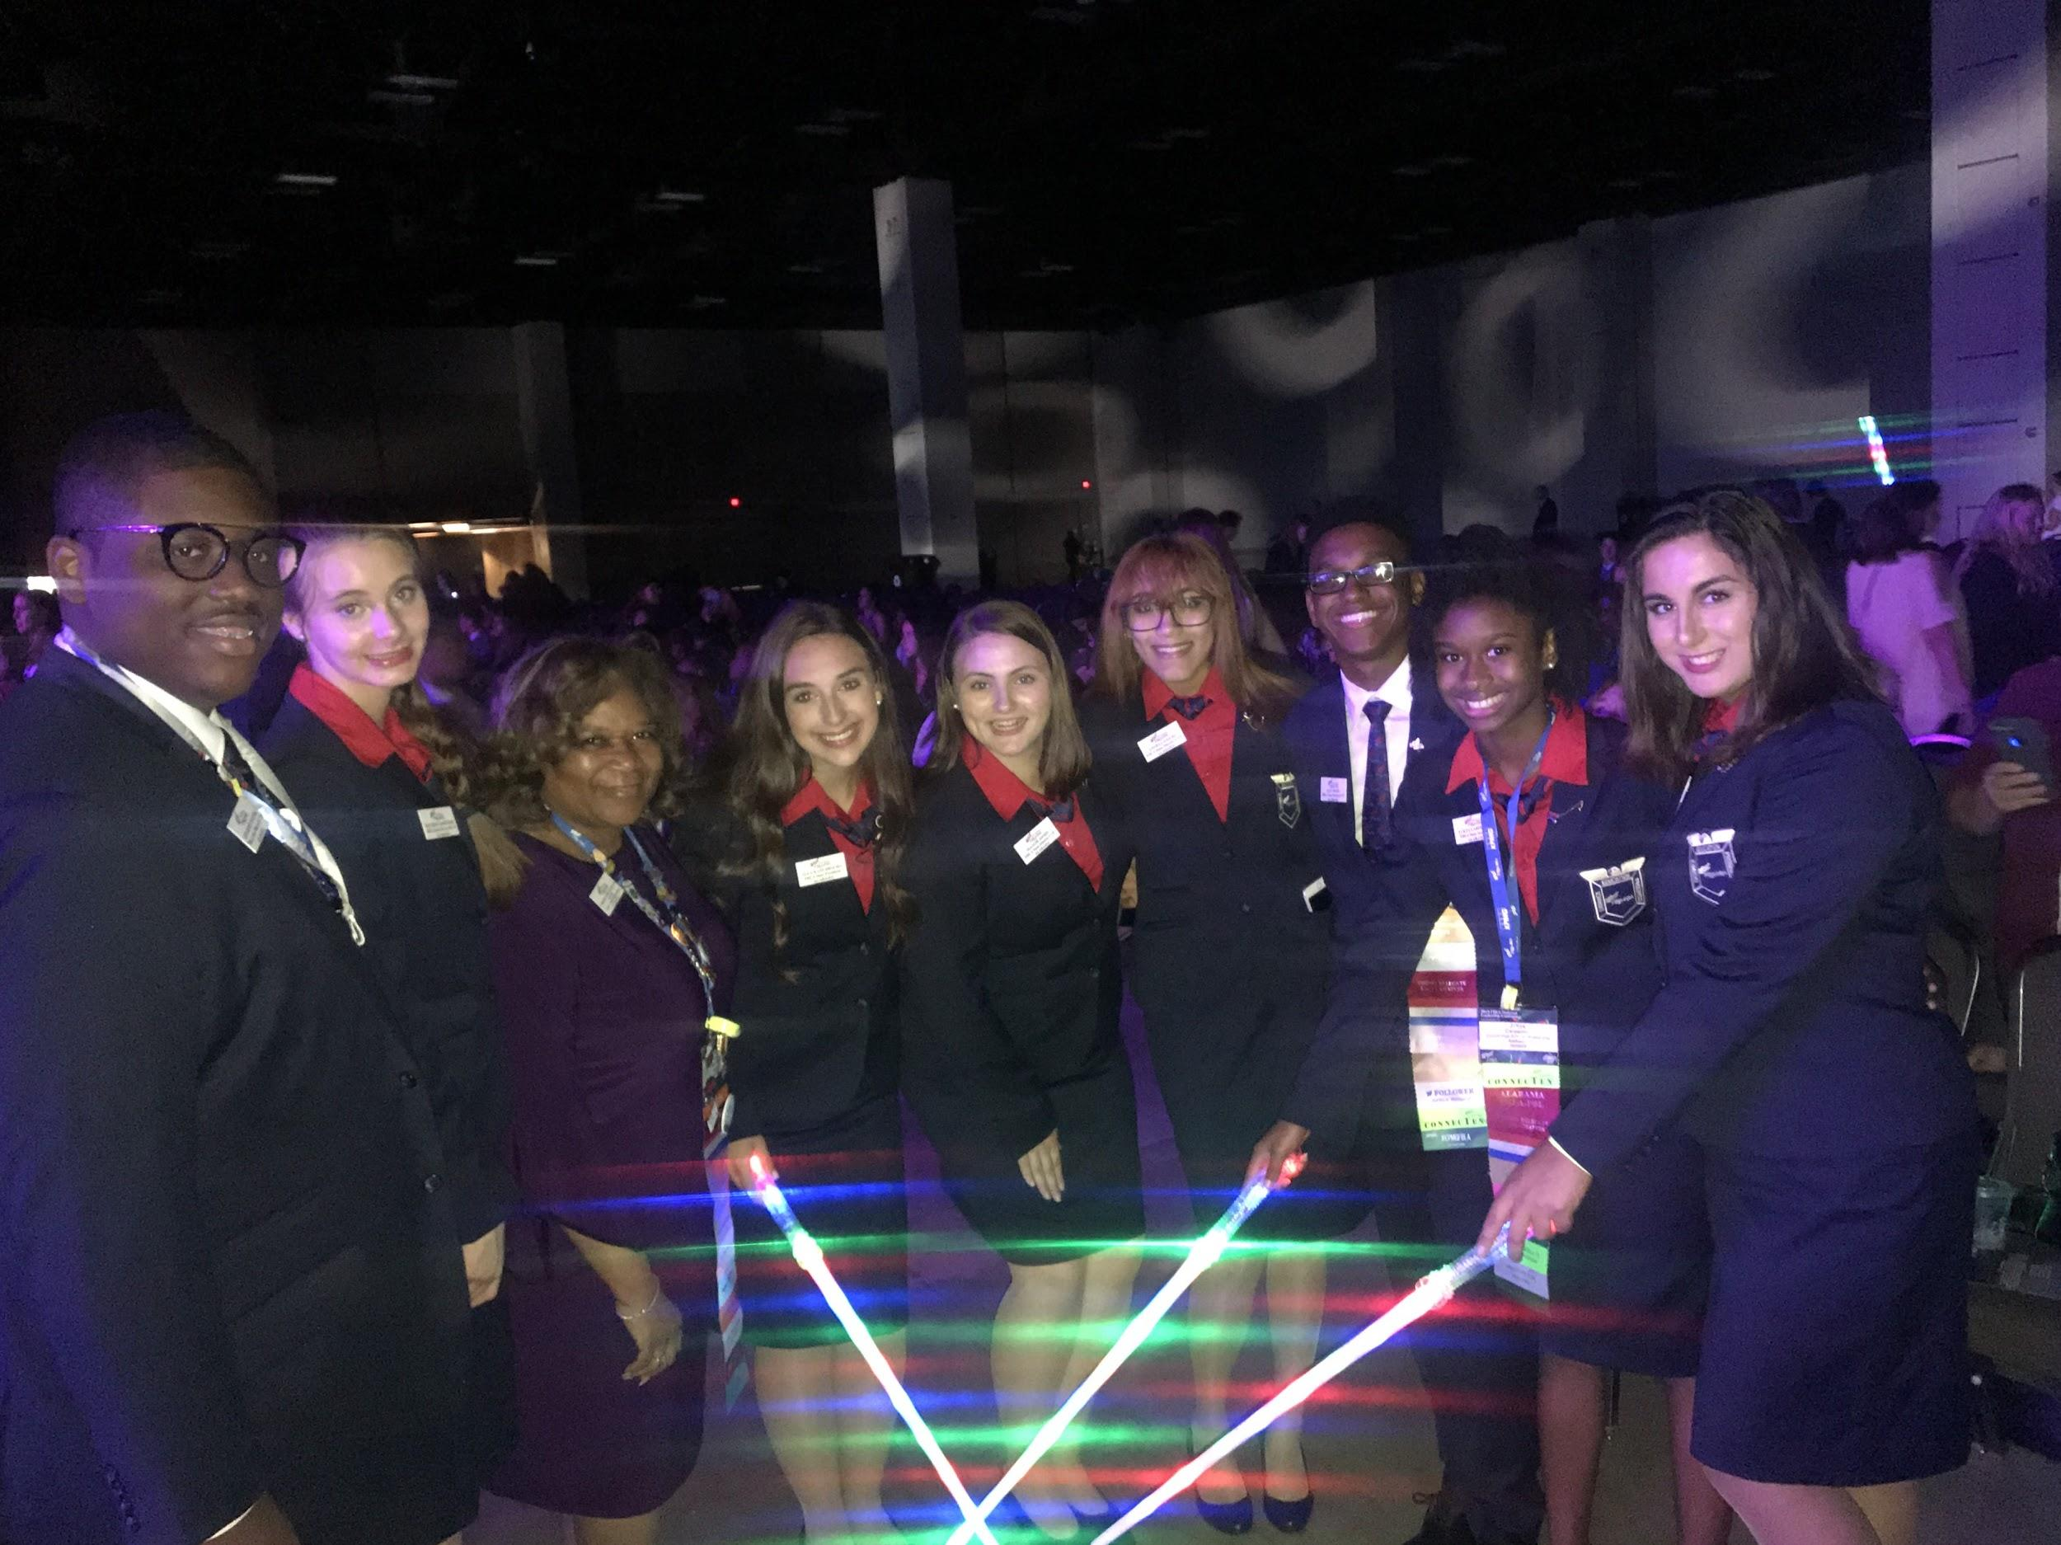
Alabama FBLA State officers and Advisers at the National Leadership Conference in San Antonio, Texas.
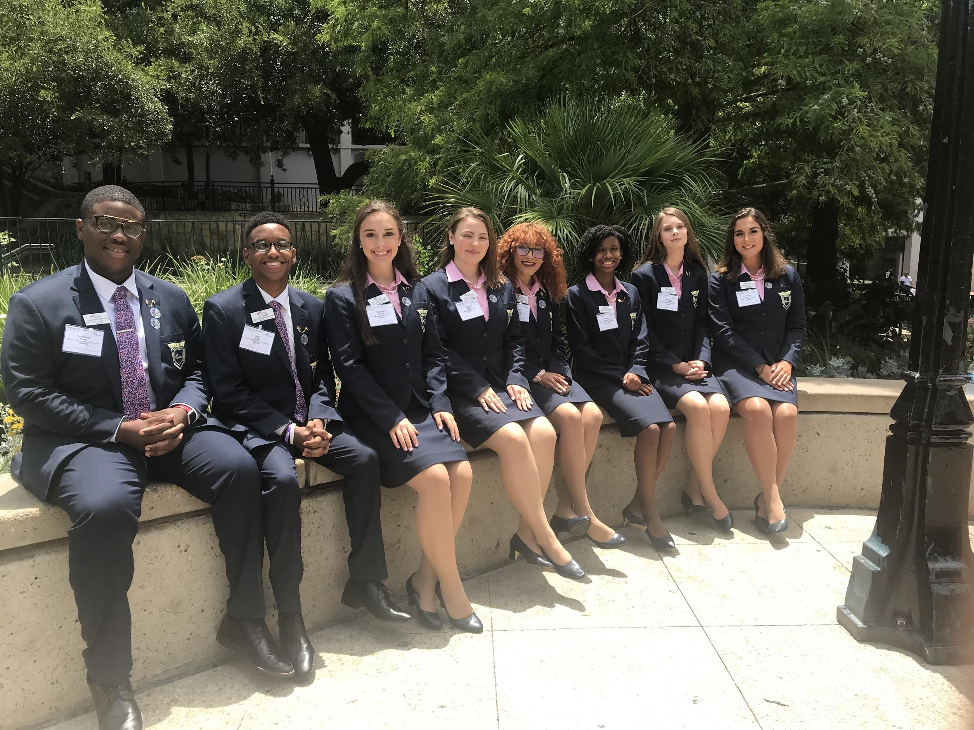 Alabama FBLA State Officers during Institute for Leaders; which they would later graduate from.
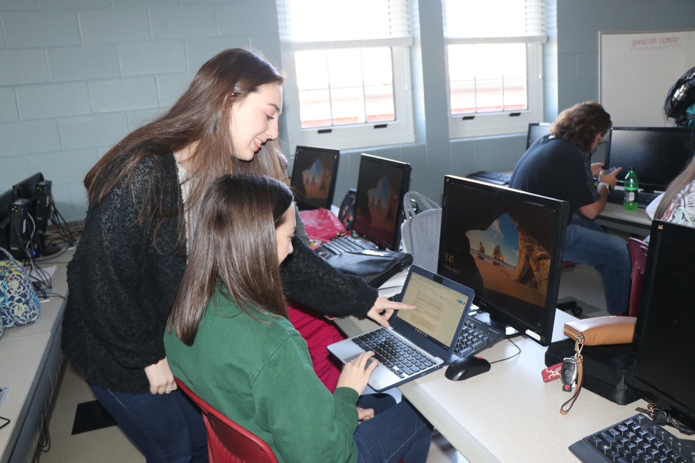

Local Sylacauga FBLA member assisting her classmates on a script for the March of Dimes Organization.

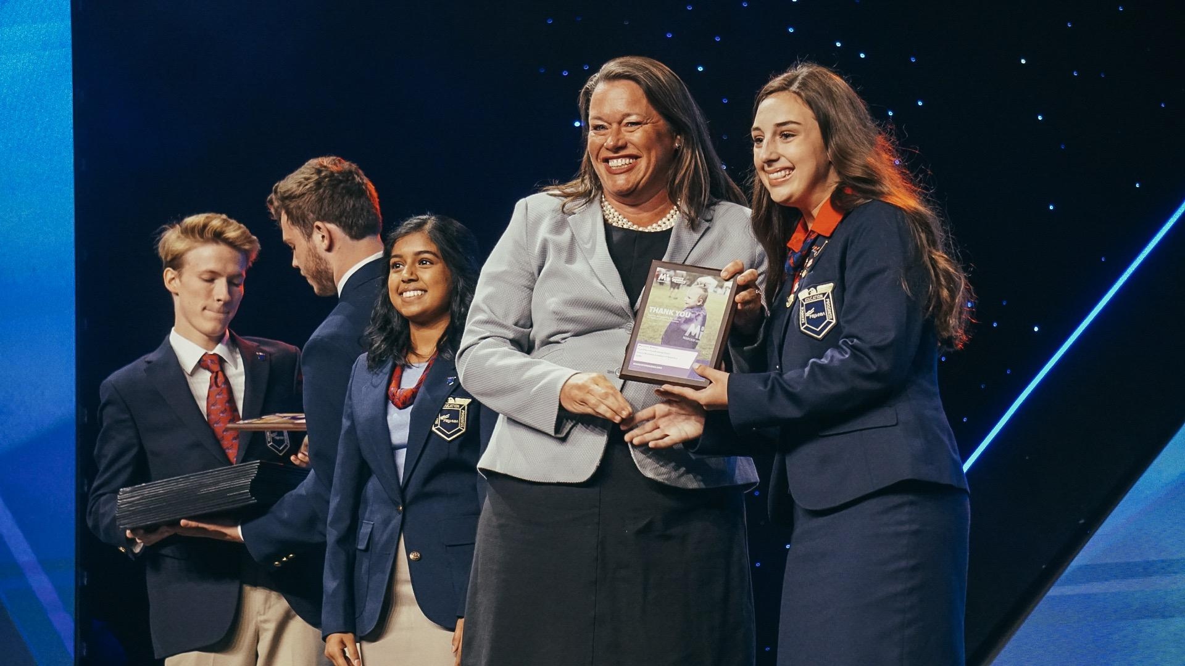

Alabama FBLA was recognized first in the nation for exceeding $95,000 in donations.

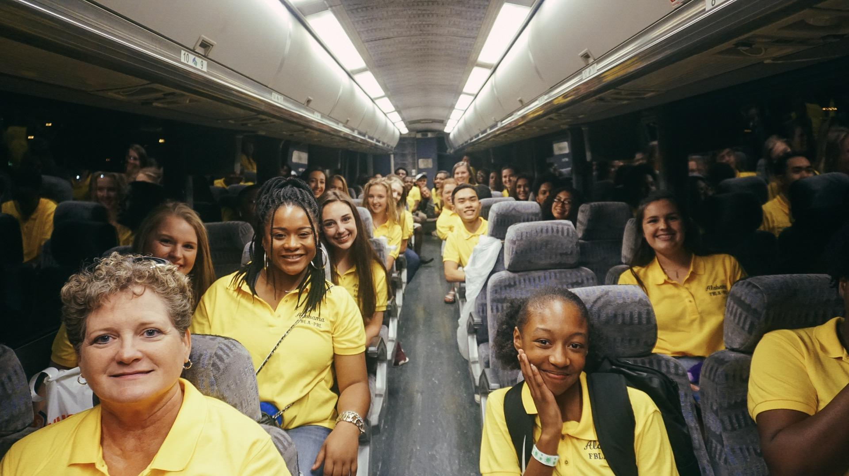A group of local FBLA members and advisers prepare for their journey back after a fun filled night at Dave and Busters.

